**Presentation Notes**

1. Summarize the main features of a Code Repository
   1. Files have version control
   2. File changes are there for easily managed
   3. Interface is designed efficiency
   4. Files are submitted using ‘comment update’
2. List some differences between a Code Repository and other file sharing services

Code repository lacks the online editing tools like other provided by other services and

It doesn’t include any of the business/education tools  
fills have vision control

1. List some of the reasons why we are using GitHub in this course
   1. It is the most popular service in the software development community
   2. Its free to use and is publically available
   3. Many custom tools and utilities
2. You will be using 2 different GitHub repositories in this course. Explain what they are:
3. Label the following parts of the GitHub interface using the diagram below.
   1. File content link
   2. Timestamp information
   3. Button to upload files
   4. Repository link & path information

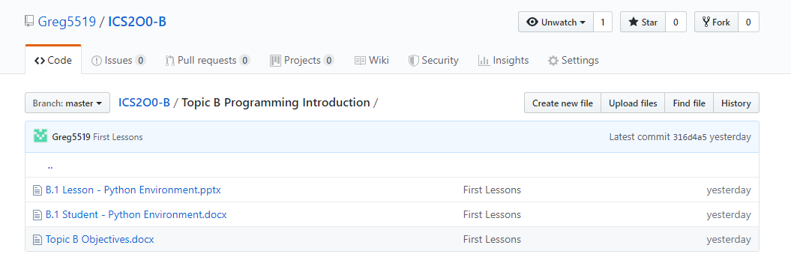

1. List some privacy concerns related to using GitHub.

* Content you post on repository is visible to anyone
* Your account profile is visible to anyone

1. Summarize the guidelines you should follow when creating a user account for school work on 3rd party software.

* Do not use you student email as a user ID
* Do not use your real full name
* Do not share your birthday or address

1. List some of the main features of a Terns of Service (TOS) agreement.
   1. Defines what misuse is
   2. Defines proper and excepted use of service
   3. Outlines membership, subscription and payment details
   4. Outlines the procedure for closing an account
   5. Clarifies the legal liability and dispute resolution process
2. List some of the main features of a Privacy Policy.
   1. Discloses what personal information of you Is collected
   2. Outlines how and when your personal information is collected
   3. Defines who your personal information is being sent to
3. Summarize the difference between a TOS and a Privacy Policy.

The TOS protects the company from you it’s not required by law but put in place for the benefit of the company

The Privacy Policy protects you from the company its required by law but not for the benefit of the company

**Module Questions**

1. Review the Terms of Service (TOS) agreement for the GitHub service.
   1. Open the link: (<https://help.github.com/articles/github-terms-of-service/>)
   2. Summarize the section that confirms that you are permitted to use this software for this class.
   3. Explain what rights do you give up by using this software.
   4. Explain what limitations you have when using this software.

You must be 13 or older to create an account. You must be human. The "owner" of an Organization that was created under these Terms has ultimate administrative control over that Organization and the Content within it. Within the Service, an owner can manage User access to the Organization’s data and projects.. You retain all moral rights to Your Content that you upload, publish, or submit to any part of the Service, including the rights of integrity and attribution. However, you ignore these rights and agree not to state them against us, to enable us to reasonably exercise the rights granted in Section D.4, but not otherwise.

D. The limitations I have when using the software is the use, disclosure, or display of your User-Generated Content,

1. Review the Privacy Policy for the GitHub service.
   1. Open the link: (<https://help.github.com/articles/github-privacy-statement/>)
   2. What information does GitHub collect and track?

The information GitHub collect and track is some personal information from the user. They only require a little amount of personal information that is given to you.

* 1. Summarize how GitHub shares your information.

we do share User Personal Information with your permission, so we can perform services you have requested or communicate on your behalf. For example, if you purchase an integration or other Developer Product from our Marketplace, we will share your account name to allow the integrator to provide you services. GitHub

How does GitHub communicate with you?

We share information to provide the service to you, to comply with your requests, or with our vendors. We do not host advertising on GitHub and we do not sell your personal information. You can see a list of the vendors that access your personal information.

GitHub will be used to share course files in a similar way to MyClass or D2L. The reason we are using GitHub is because this is the tool preferred by many software developers and is the most common way to share computer code on the internet.

The Peel School Board is concerned about the privacy and safety of its students and has issued the following guidelines for using third party applications:

* Do not provide: First & Last Name
* Do not provide: Birthday
* Do not provide: Personal Address & Contact Information
* Do not provide: Student Number
* Your @pdsb.net email address can be used but cannot be used as a login id.

1. Based on your understanding of the GitHub privacy policy, list two benefits and two drawbacks of following the Peel Board guidelines listed above.

With the guidelines there it is more secure as it does not list your first and last name. It also does not reveal your age as it does not ask for your birthday. A drawback could be harder to find specific people because they don’t show first or last names. A drawback is that some people provide their personal emails which gives out personal information risking the guidelines.

1. Create an account on GitHub.com following the Peel Board guidelines listed above.
   1. **NOTE:** Make sure to select the free student plan when creating your account.

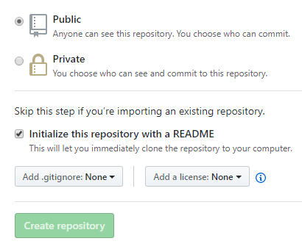

1. Create a new Repository for your ICS2O0 course work.
   1. Give your repository a meaningful name like “ICS2O0_Work”
   2. **Note:** Make sure to select "Public Repository"
   3. **Note:** Make sure to select “Include a ReadMe file”
2. Email Mr. Nestor (p0079141@pdsb.net) the following information:
3. Your Name
4. The link to your repository

Your personal GitHub repository will be used to store and manage your work for this course. You should save partially completed work in your repository and you can update it at any time from school or at home. GitHub automatically keeps track of updates to your files. You should NEVER make multiple VERSION COPIES of your work files.

Your repository should be shared with your teacher and with other members of your work group.

1. Open Mr. Nestor's repository for this class.
   1. You should have bookmarked the link in an earlier part of this lesson.
   2. This repository is the source for all course information and lesson files (much like D2L or Google Classroom is used by other teachers).
   3. Note the structure and organization of Mr. Nestor’s repository. In particular, note the folders such as “Topic A”, "Topic B", etc.
2. Duplicate the organization structure and folder names in your personal repository.
   1. Your personal GitHub repository will be used to upload and manage your work completed for this course.
   2. Your repository needs to be well organized so that Mr. Nestor can easily find your work and give you credit for it.
   3. **NOTE:** There is a “trick” required to create folders in GitHub.
   4. See if you can find this trick and share it with your neighbours.
   5. Check-in with Mr. Nestor to make sure you have found the trick.
3. Upload your answers to this module (i.e. the “A.1 Student - GitHub Repositories” )
   1. Make sure to store it in the proper folder.
   2. Use the "Upload" button in the GitHub screen and drag and drop you file.
   3. Make sure to "Commit" your changes at the bottom of the upload screen.
   4. You can upload and commit partially completed work now and then upload the same file again at a later time; GitHub automatically keeps track of your changes.

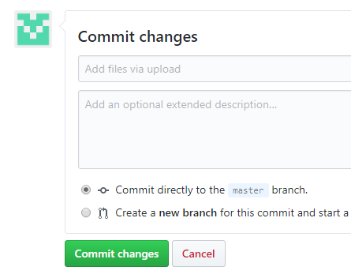

1. Email Mr. Nestor ([p0079141@pdsb.net](mailto:p0079141@pdsb.net)) when you have completed this work.

Work will be submitted (handed in) by uploading it to your repository . ONLY work uploaded to your repository will be considered handed in and will be marked.